**PL/SQL EXERCISES**

**Exercise 1: Control Structures**

**Scenario 1:** The bank wants to apply a discount to loan interest rates for customers above 60 years old.

**Sample Data:**

-- Insert into Customers

INSERT INTO Customers (CustomerID, Name, DOB, Balance, LastModified)

VALUES

(1, 'John Doe', '1985-05-15', 1000.00, CURDATE()),

(2, 'Jane Smith', '1960-07-20', 1500.00, CURDATE());

-- Insert into Loans

INSERT INTO Loans (LoanID, CustomerID, LoanAmount, InterestRate, StartDate, EndDate)

VALUES

(1, 1, 5000.00, 5.00, CURDATE(), '2025-07-29'), -- Due in 30 days from June 29, 2025

(2, 2, 3000.00, 4.00, CURDATE(), '2026-06-30'); -- Not due within 30 days

**Scenario 1: Apply a 1% discount to loan interest rates for customers above 60 years old.**

DELIMITER //

CREATE PROCEDURE ApplySeniorDiscount()

BEGIN

DECLARE done INT DEFAULT FALSE;

DECLARE cust_id INT;

DECLARE cust_dob DATE;

DECLARE loan_id INT;

DECLARE curr_rate DECIMAL(5, 2);

DECLARE cur CURSOR FOR

SELECT c.CustomerID, c.DOB, l.LoanID, l.InterestRate

FROM Customers c

JOIN Loans l ON c.CustomerID = l.CustomerID;

DECLARE CONTINUE HANDLER FOR NOT FOUND SET done = TRUE;

OPEN cur;

read_loop: LOOP

FETCH cur INTO cust_id, cust_dob, loan_id, curr_rate;

IF done THEN

LEAVE read_loop;

END IF;

IF TIMESTAMPDIFF(YEAR, cust_dob, CURDATE()) > 60 THEN

UPDATE Loans

SET InterestRate = curr_rate - 1

WHERE LoanID = loan_id;

END IF;

END LOOP;

CLOSE cur;

END //

DELIMITER ;

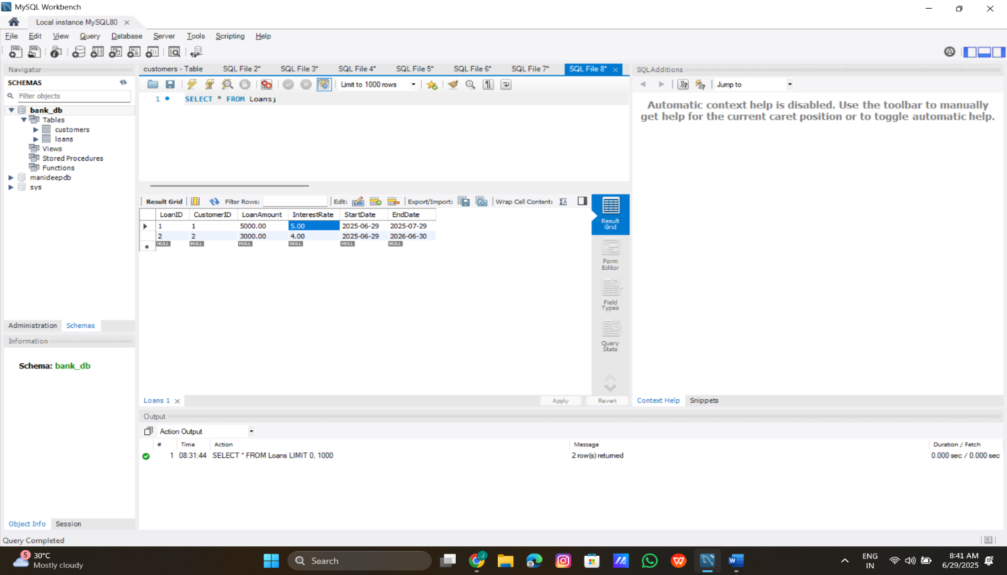**Output:**

**Scenario 2: A customer can be promoted to VIP status based on their balance.**

**Sample Data:**

INSERT INTO Customers (CustomerID, Name, DOB, Balance, LastModified)

VALUES

(1, 'John Doe', '1985-05-15', 1000.00, CURDATE()),

(2, 'Jane Smith', '1960-07-20', 1500.00, CURDATE()),

(3, 'Mike Wilson', '1990-01-10', 12000.00, CURDATE()); -- Added to test VIP status

**Code:**

DELIMITER //

CREATE PROCEDURE SetVIPStatus()

BEGIN

DECLARE done INT DEFAULT FALSE;

DECLARE cust_id INT;

DECLARE cust_balance DECIMAL(10, 2);

DECLARE cur CURSOR FOR

SELECT CustomerID, Balance

FROM Customers;

DECLARE CONTINUE HANDLER FOR NOT FOUND SET done = TRUE;

OPEN cur;

read_loop: LOOP

FETCH cur INTO cust_id, cust_balance;

IF done THEN

LEAVE read_loop;

END IF;

IF cust_balance > 10000 THEN

UPDATE Customers

SET IsVIP = TRUE

WHERE CustomerID = cust_id;

END IF;

END LOOP;

CLOSE cur;

END //

DELIMITER ;

**Output:**

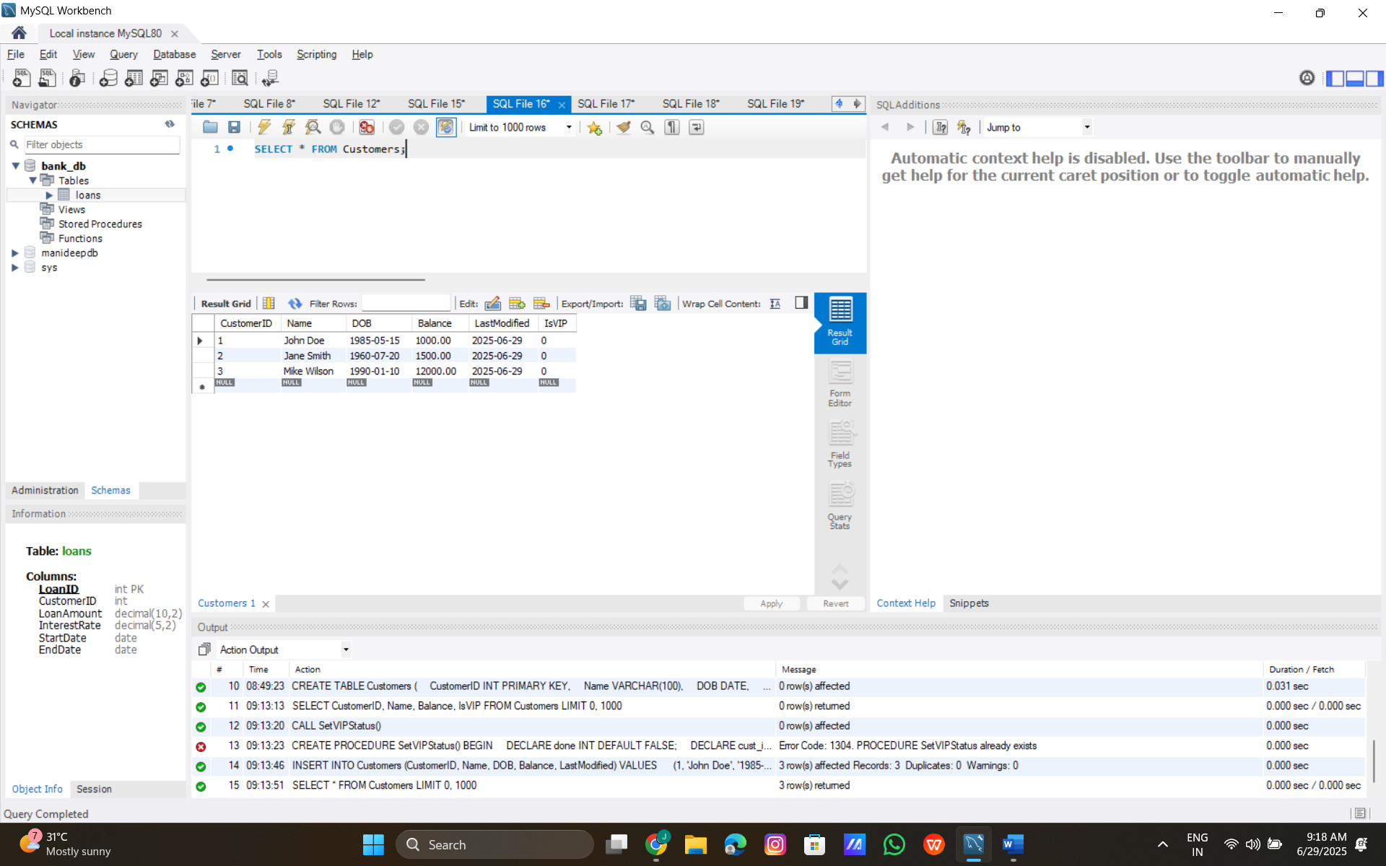

**Scenario 3: The bank wants to send reminders to customers whose loans are due within the next 30 days.**

**Sample Data:**

INSERT INTO Customers (CustomerID, Name, DOB, Balance, LastModified)

VALUES

(1, 'John Doe', '1985-05-15', 1000.00, CURDATE()),

(2, 'Jane Smith', '1960-07-20', 1500.00, CURDATE());

INSERT INTO Loans (LoanID, CustomerID, LoanAmount, InterestRate, StartDate, EndDate)

VALUES

(1, 1, 5000.00, 5.00, CURDATE(), '2025-07-15'), -- Due within 30 days

(2, 2, 3000.00, 4.00, CURDATE(), '2026-06-30'); -- Due outside 30 days

**Code:**

DELIMITER //

CREATE PROCEDURE LoanDueReminders()

BEGIN

DECLARE done INT DEFAULT FALSE;

DECLARE cust_id INT;

DECLARE cust_name VARCHAR(100);

DECLARE loan_id INT;

DECLARE due_date DATE;

DECLARE cur CURSOR FOR

SELECT c.CustomerID, c.Name, l.LoanID, l.EndDate

FROM Customers c

JOIN Loans l ON c.CustomerID = l.CustomerID

WHERE l.EndDate BETWEEN CURDATE() AND DATE_ADD(CURDATE(), INTERVAL 30 DAY);

DECLARE CONTINUE HANDLER FOR NOT FOUND SET done = TRUE;

OPEN cur;

read_loop: LOOP

FETCH cur INTO cust_id, cust_name, loan_id, due_date;

IF done THEN

LEAVE read_loop;

END IF;

SELECT CONCAT('Reminder: Dear ', cust_name, ', your loan (ID: ', loan_id, ') is due on ', due_date) AS Reminder;

END LOOP;

CLOSE cur;

END //

DELIMITER ;

**Output:**

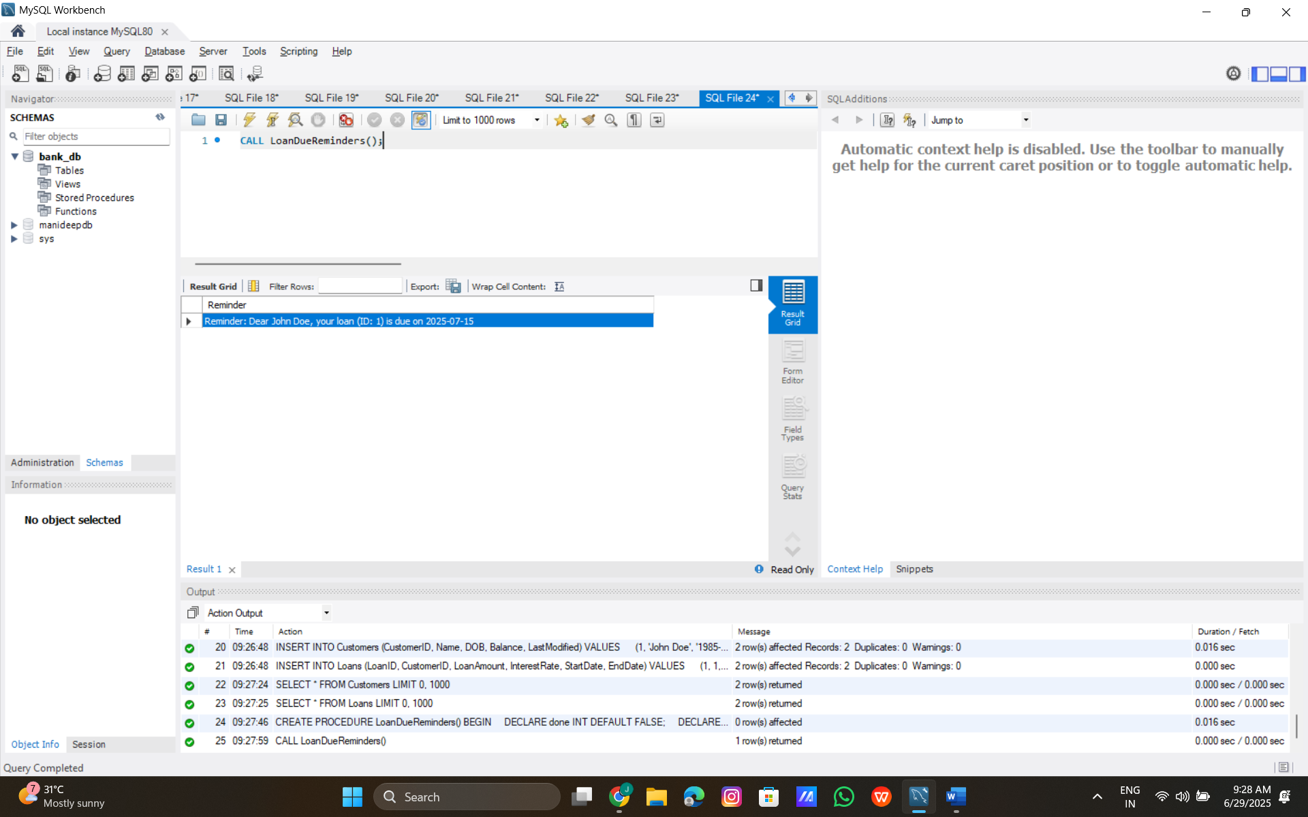

**Exercise 2: Error Handling.**

**Scenario 1: Handle exceptions during fund transfers between accounts.**

**Code:**

DELIMITER //

CREATE PROCEDURE SafeTransferFunds(

IN p_from_account INT,

IN p_to_account INT,

IN p_amount DECIMAL(10, 2)

)

BEGIN

DECLARE EXIT HANDLER FOR SQLEXCEPTION

BEGIN

ROLLBACK;

INSERT INTO AuditLog (TransactionID, AccountID, TransactionDate, Amount, TransactionType, LogDate)

VALUES (NULL, p_from_account, CURDATE(), p_amount, 'Error', CURDATE());

SELECT 'Error: Transaction failed and rolled back' AS ErrorMessage;

END;

START TRANSACTION;

IF (SELECT Balance FROM Accounts WHERE AccountID = p_from_account) < p_amount THEN

SIGNAL SQLSTATE '45000'

SET MESSAGE_TEXT = 'Insufficient funds in source account';

END IF;

UPDATE Accounts

SET Balance = Balance - p_amount

WHERE AccountID = p_from_account;

UPDATE Accounts

SET Balance = Balance + p_amount

WHERE AccountID = p_to_account;

INSERT INTO Transactions (TransactionID, AccountID, TransactionDate, Amount, TransactionType)

VALUES ((SELECT COALESCE(MAX(TransactionID), 0) + 1 FROM Transactions), p_from_account, CURDATE(), p_amount, 'Transfer');

COMMIT;

SELECT 'Transfer successful' AS Message;

END //

DELIMITER ;

**Outputs:**

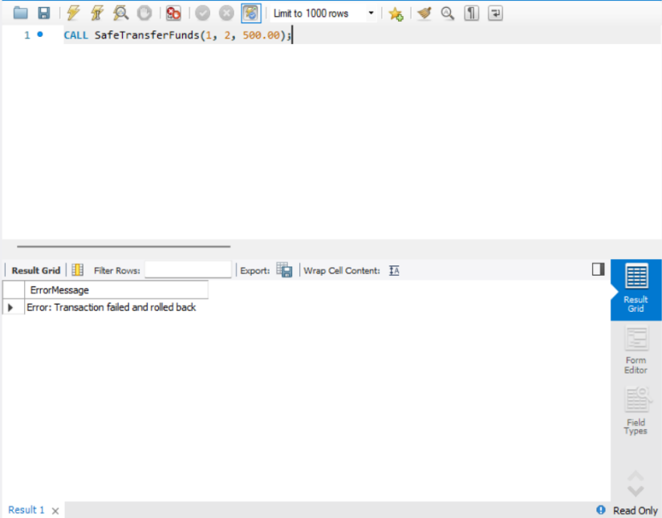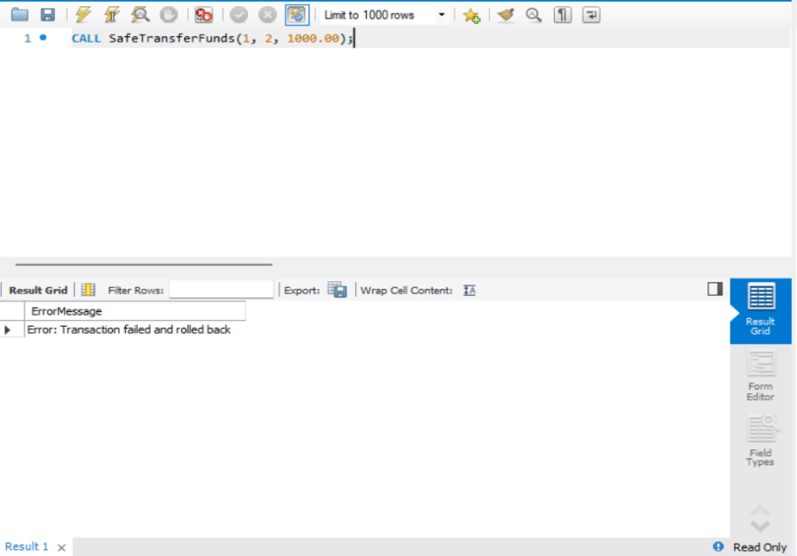**VALID TRANSFER INVALID TRANSFER**

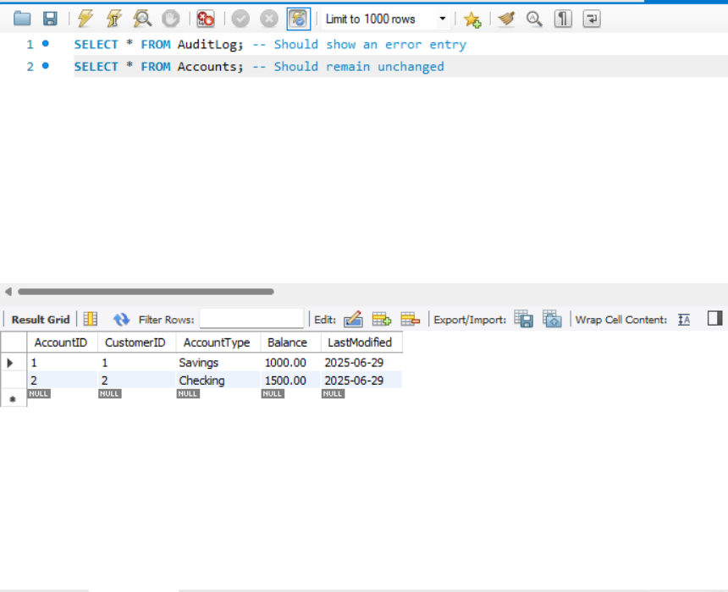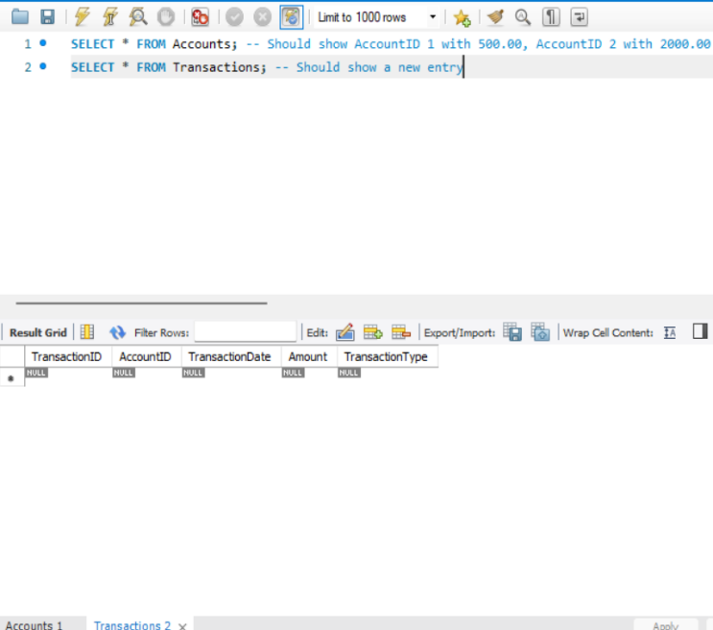**SUCCESSFUL TRANSFER FAILED TRANSFER**

**Scenario 2: Manage errors when updating employee salaries.**

**CODE:**

DELIMITER //

CREATE PROCEDURE CheckAccountBalance(

IN p_account_id INT,

OUT p_balance DECIMAL(10, 2)

)

BEGIN

SELECT Balance INTO p_balance

FROM Accounts

WHERE AccountID = p_account_id;

IF p_balance IS NULL THEN

SIGNAL SQLSTATE '45000'

SET MESSAGE_TEXT = 'Account not found';

END IF;

END //

DELIMITER ;

**Output:**

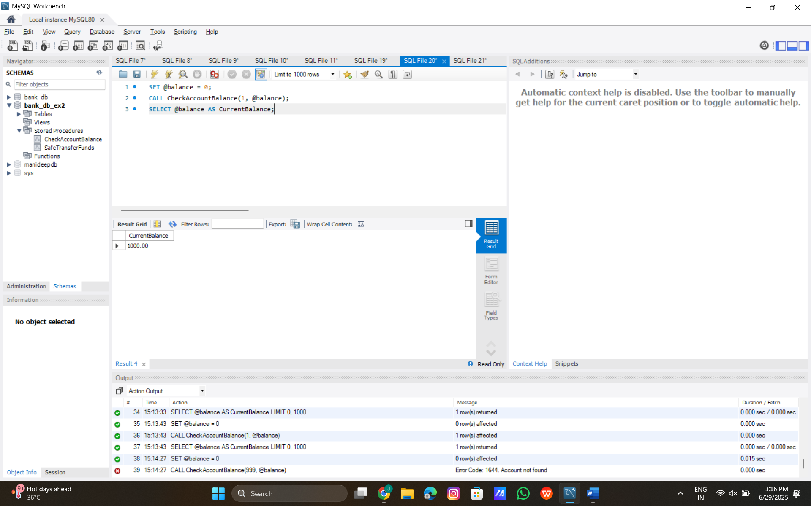

**Scenario 3:** **Ensure data integrity when adding a new customer.**

**Code:**

-- Insert into Customers

INSERT INTO Customers (CustomerID, Name, DOB, Balance, LastModified)

VALUES

(1, 'John Doe', '1985-05-15', 1000.00, CURDATE()),

(2, 'Jane Smith', '1960-07-20', 1500.00, CURDATE());

-- Insert into Accounts

INSERT INTO Accounts (AccountID, CustomerID, AccountType, Balance, LastModified)

VALUES

(1, 1, 'Savings', 1000.00, CURDATE()), -- John Doe's account

(2, 2, 'Checking', 1500.00, CURDATE()); -- Jane Smith's account

**Output:**

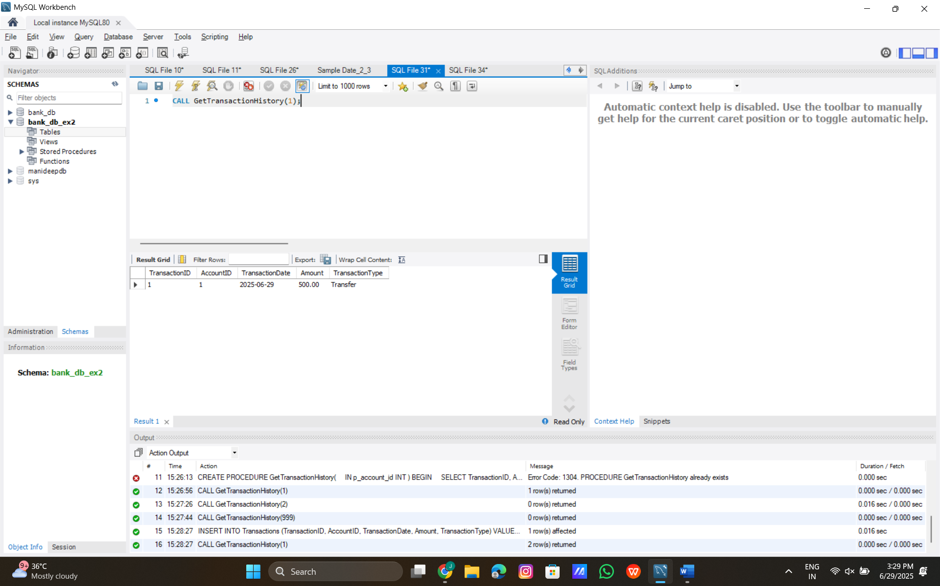

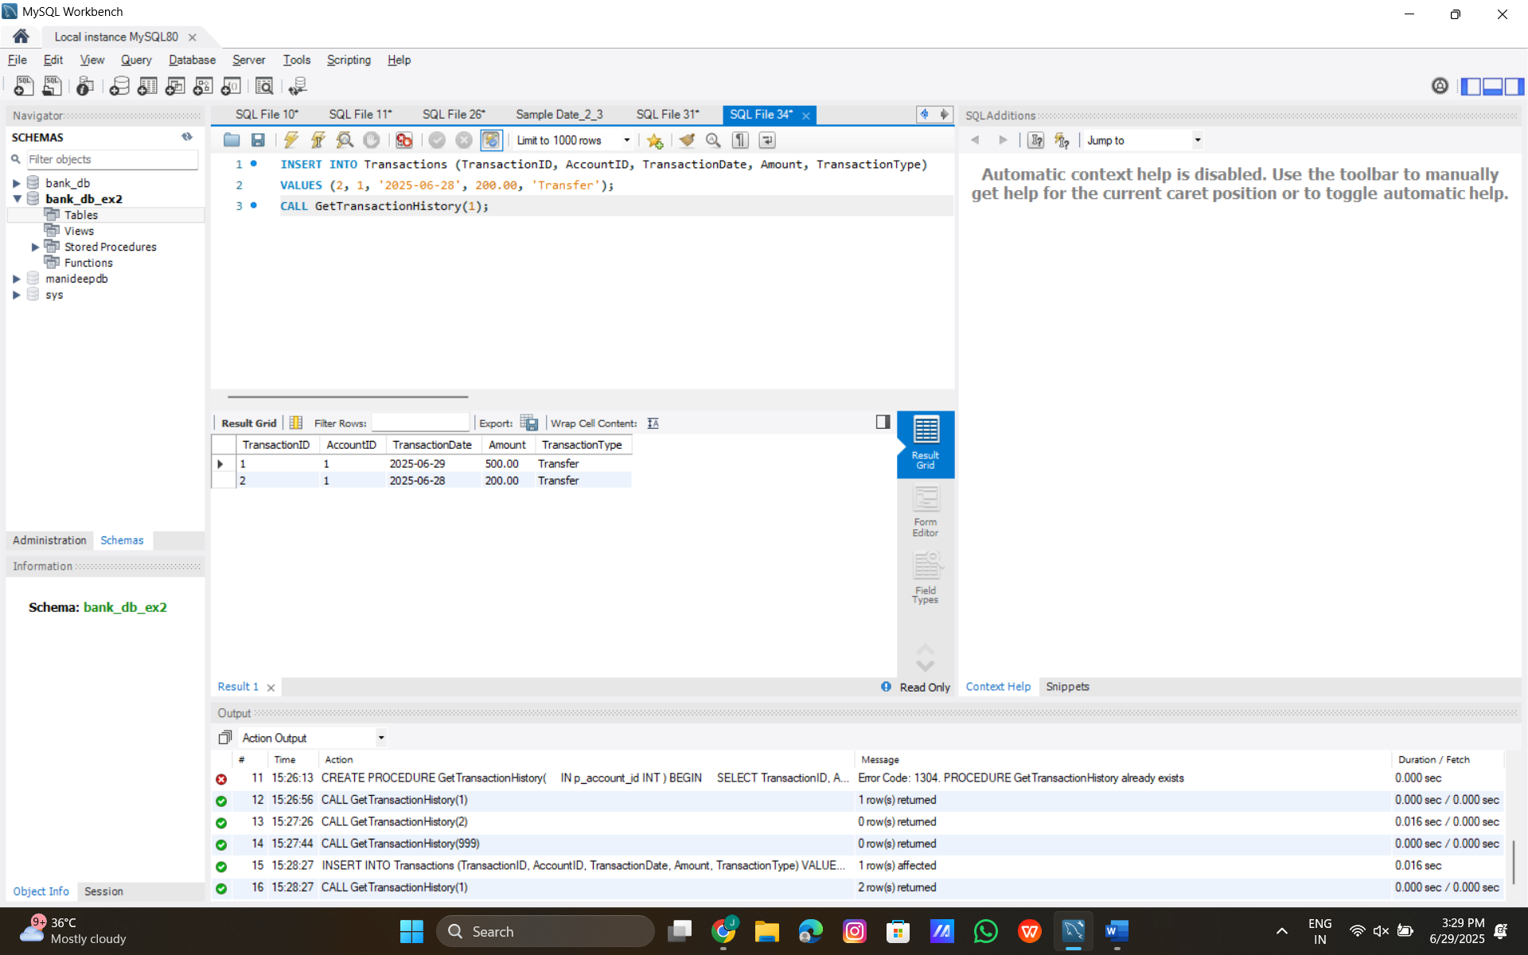

**Exercise 3: Stored Procedures**

**Scenario 1:** **The bank needs to process monthly interest for all savings accounts.**

**Sample Data:**

-- Insert into Customers

INSERT INTO Customers (CustomerID, Name, DOB, Balance, LastModified)

VALUES

(1, 'John Doe', '1985-05-15', 1000.00, CURDATE()),

(2, 'Jane Smith', '1960-07-20', 1500.00, CURDATE());

-- Insert into Accounts

INSERT INTO Accounts (AccountID, CustomerID, AccountType, Balance, LastModified)

VALUES

(1, 1, 'Savings', 1000.00, CURDATE()), -- John Doe's account

(2, 2, 'Checking', 1500.00, CURDATE()); -- Jane Smith's account

-- Insert into Transactions (e.g., from Scenario 1 or manually)

INSERT INTO Transactions (TransactionID, AccountID, TransactionDate, Amount, TransactionType)

VALUES

(1, 1, CURDATE(), 500.00, 'Transfer'), -- Transfer from John to Jane

(2, 2, '2025-06-28', 300.00, 'Deposit'); -- Jane's deposit

**Generate Account Summary:**

DELIMITER //

CREATE PROCEDURE GenerateAccountSummary(

IN p_customer_id INT

)

BEGIN

SELECT

c.CustomerID,

c.Name,

a.AccountID,

a.AccountType,

a.Balance,

t.TransactionID,

t.TransactionDate,

t.Amount,

t.TransactionType

FROM Customers c

LEFT JOIN Accounts a ON c.CustomerID = a.CustomerID

LEFT JOIN Transactions t ON a.AccountID = t.AccountID

WHERE c.CustomerID = p_customer_id

ORDER BY t.TransactionDate DESC;

END //

DELIMITER ;

**Output:**

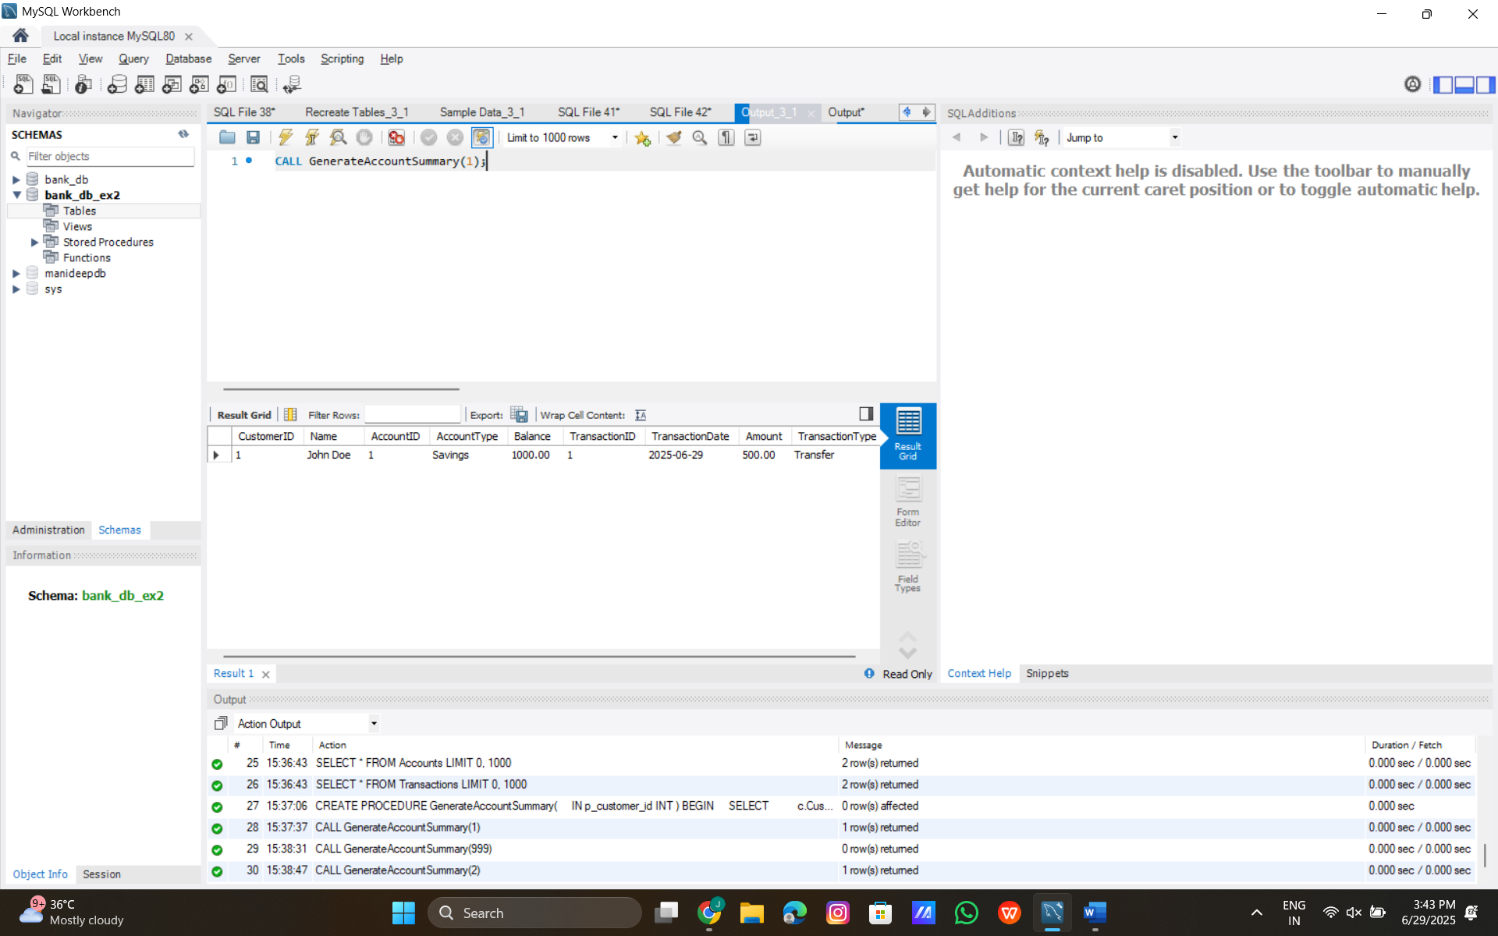

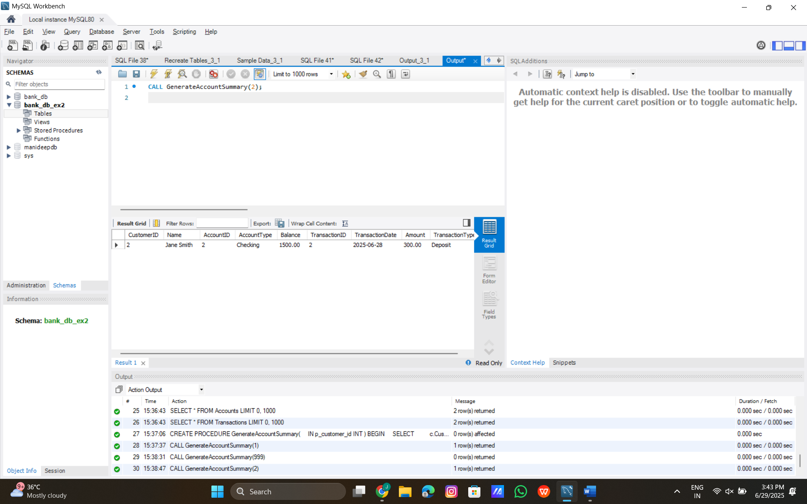

**Scenario 2:** **The bank wants to implement a bonus scheme for employees based on their performance.**

**Sample Data:**

-- Insert into Customers

INSERT INTO Customers (CustomerID, Name, DOB, Balance, LastModified)

VALUES

(1, 'John Doe', '1985-05-15', 1000.00, CURDATE()),

(2, 'Jane Smith', '1960-07-20', 1500.00, CURDATE());

-- Insert into Accounts

INSERT INTO Accounts (AccountID, CustomerID, AccountType, Balance, LastModified)

VALUES

(1, 1, 'Savings', 1000.00, CURDATE()), -- John Doe's account

(2, 2, 'Checking', 1500.00, CURDATE()); -- Jane Smith's account

**Apply Interest To Accounts:**

DELIMITER //

CREATE PROCEDURE ApplyInterestToAccounts()

BEGIN

DECLARE done INT DEFAULT FALSE;

DECLARE v_account_id INT;

DECLARE v_balance DECIMAL(10, 2);

DECLARE v_interest DECIMAL(10, 2);

DECLARE v_new_balance DECIMAL(10, 2);

DECLARE cur CURSOR FOR SELECT AccountID, Balance FROM Accounts;

DECLARE CONTINUE HANDLER FOR NOT FOUND SET done = TRUE;

-- Start transaction to ensure atomicity

START TRANSACTION;

OPEN cur;

read_loop: LOOP

FETCH cur INTO v_account_id, v_balance;

IF done THEN

LEAVE read_loop;

END IF;

-- Calculate interest (2% annual rate, prorated for 1 day)

SET v_interest = v_balance * (0.02 / 365);

SET v_new_balance = v_balance + v_interest;

-- Update account balance

UPDATE Accounts

SET Balance = v_new_balance,

LastModified = CURDATE()

WHERE AccountID = v_account_id;

-- Log the interest application as a transaction

INSERT INTO Transactions (TransactionID, AccountID, TransactionDate, Amount, TransactionType)

VALUES ((SELECT COALESCE(MAX(TransactionID), 0) + 1 FROM Transactions), v_account_id, CURDATE(), v_interest, 'Interest');

END LOOP;

CLOSE cur;

COMMIT;

SELECT 'Interest applied successfully' AS Message;

END //

DELIMITER ;

**Output:**

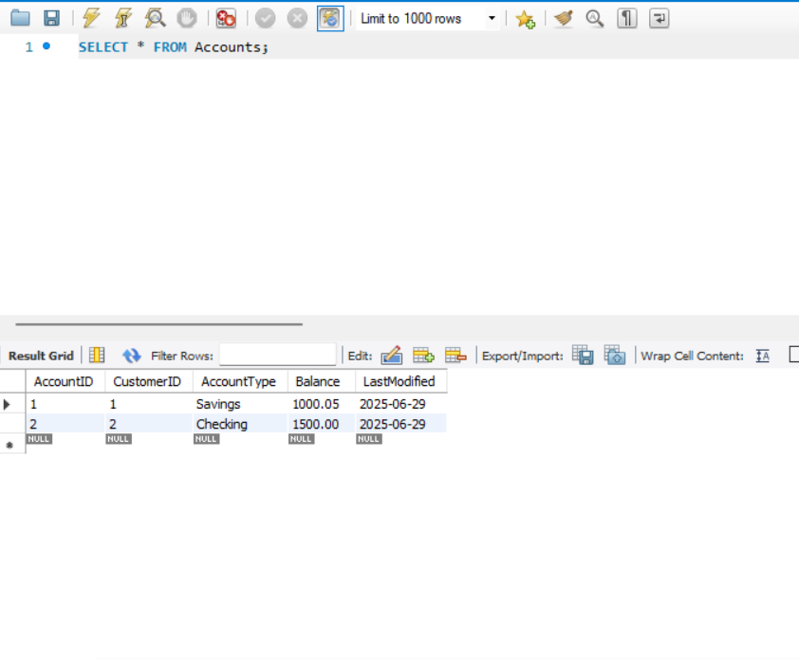

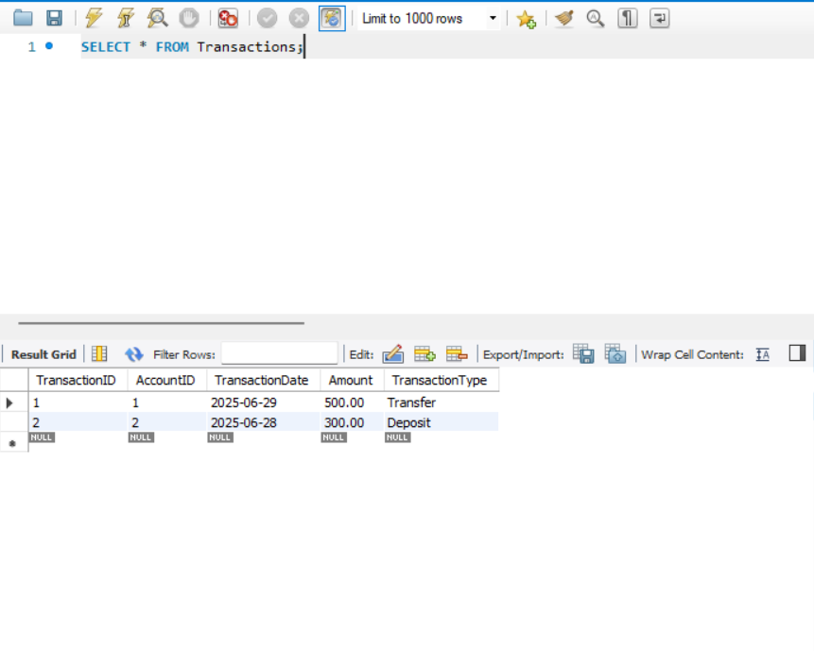

**Exercise 4: Functions**

**Scenario 1:** **Calculate the age of customers for eligibility checks.**

**Sample Data:**

USE bank_db_ex4;

-- Insert into Customers

INSERT INTO Customers (CustomerID, Name, DOB, Balance, LastModified)

VALUES (1, 'John Doe', '1985-05-15', 1000.00, CURDATE());

INSERT INTO Customers (CustomerID, Name, DOB, Balance, LastModified)

VALUES (2, 'Jane Smith', '1990-07-20', 1500.00, CURDATE());

-- Insert into Accounts

INSERT INTO Accounts (AccountID, CustomerID, AccountType, Balance, LastModified)

VALUES (1, 1, 'Savings', 1000.00, CURDATE());

INSERT INTO Accounts (AccountID, CustomerID, AccountType, Balance, LastModified)

VALUES (2, 2, 'Checking', 1500.00, CURDATE());

-- Insert into Transactions

INSERT INTO Transactions (TransactionID, AccountID, TransactionDate, Amount, TransactionType)

VALUES (1, 1, CURDATE(), 200.00, 'Deposit');

INSERT INTO Transactions (TransactionID, AccountID, TransactionDate, Amount, TransactionType)

VALUES (2, 2, CURDATE(), 300.00, 'Withdrawal');

-- Insert into Loans

INSERT INTO Loans (LoanID, CustomerID, LoanAmount, InterestRate, StartDate, EndDate)

VALUES (1, 1, 5000.00, 5.00, CURDATE(), DATE_ADD(CURDATE(), INTERVAL 60 MONTH));

-- Insert into Employees

INSERT INTO Employees (EmployeeID, Name, Position, Salary, Department, HireDate)

VALUES (1, 'Alice Johnson', 'Manager', 70000.00, 'HR', '2015-06-15');

INSERT INTO Employees (EmployeeID, Name, Position, Salary, Department, HireDate)

VALUES (2, 'Bob Brown', 'Developer', 60000.00, 'IT', '2017-03-20');

**Code:**

USE bank_db_ex4;

-- Function: CalculateAge

DELIMITER //

CREATE FUNCTION CalculateAge(p_dob DATE)

RETURNS INT

DETERMINISTIC

BEGIN

DECLARE age INT;

SET age = FLOOR(DATEDIFF(CURDATE(), p_dob) / 365.25);

RETURN age;

END //

DELIMITER ;

-- Function: CalculateMonthlyInstallment

DELIMITER //

CREATE FUNCTION CalculateMonthlyInstallment(

p_loan_amount DECIMAL(15, 2),

p_interest_rate DECIMAL(5, 2),

p_duration_years INT

)

RETURNS DECIMAL(15, 2)

DETERMINISTIC

BEGIN

DECLARE monthly_rate DECIMAL(10, 6);

DECLARE num_payments INT;

DECLARE monthly_installment DECIMAL(15, 2);

SET monthly_rate = p_interest_rate / 100 / 12;

SET num_payments = p_duration_years * 12;

IF monthly_rate = 0 THEN

SET monthly_installment = p_loan_amount / num_payments;

ELSE

SET monthly_installment = p_loan_amount * monthly_rate *

POWER(1 + monthly_rate, num_payments) /

(POWER(1 + monthly_rate, num_payments) - 1);

END IF;

RETURN monthly_installment;

END //

DELIMITER ;

-- Function: HasSufficientBalance

DELIMITER //

CREATE FUNCTION HasSufficientBalance(

p_account_id INT,

p_amount DECIMAL(15, 2)

)

RETURNS BOOLEAN

DETERMINISTIC

BEGIN

DECLARE account_balance DECIMAL(15, 2);

SELECT Balance INTO account_balance

FROM Accounts

WHERE AccountID = p_account_id;

IF account_balance IS NULL THEN

RETURN FALSE;

END IF;

RETURN account_balance >= p_amount;

END //

DELIMITER ;

**Output:**

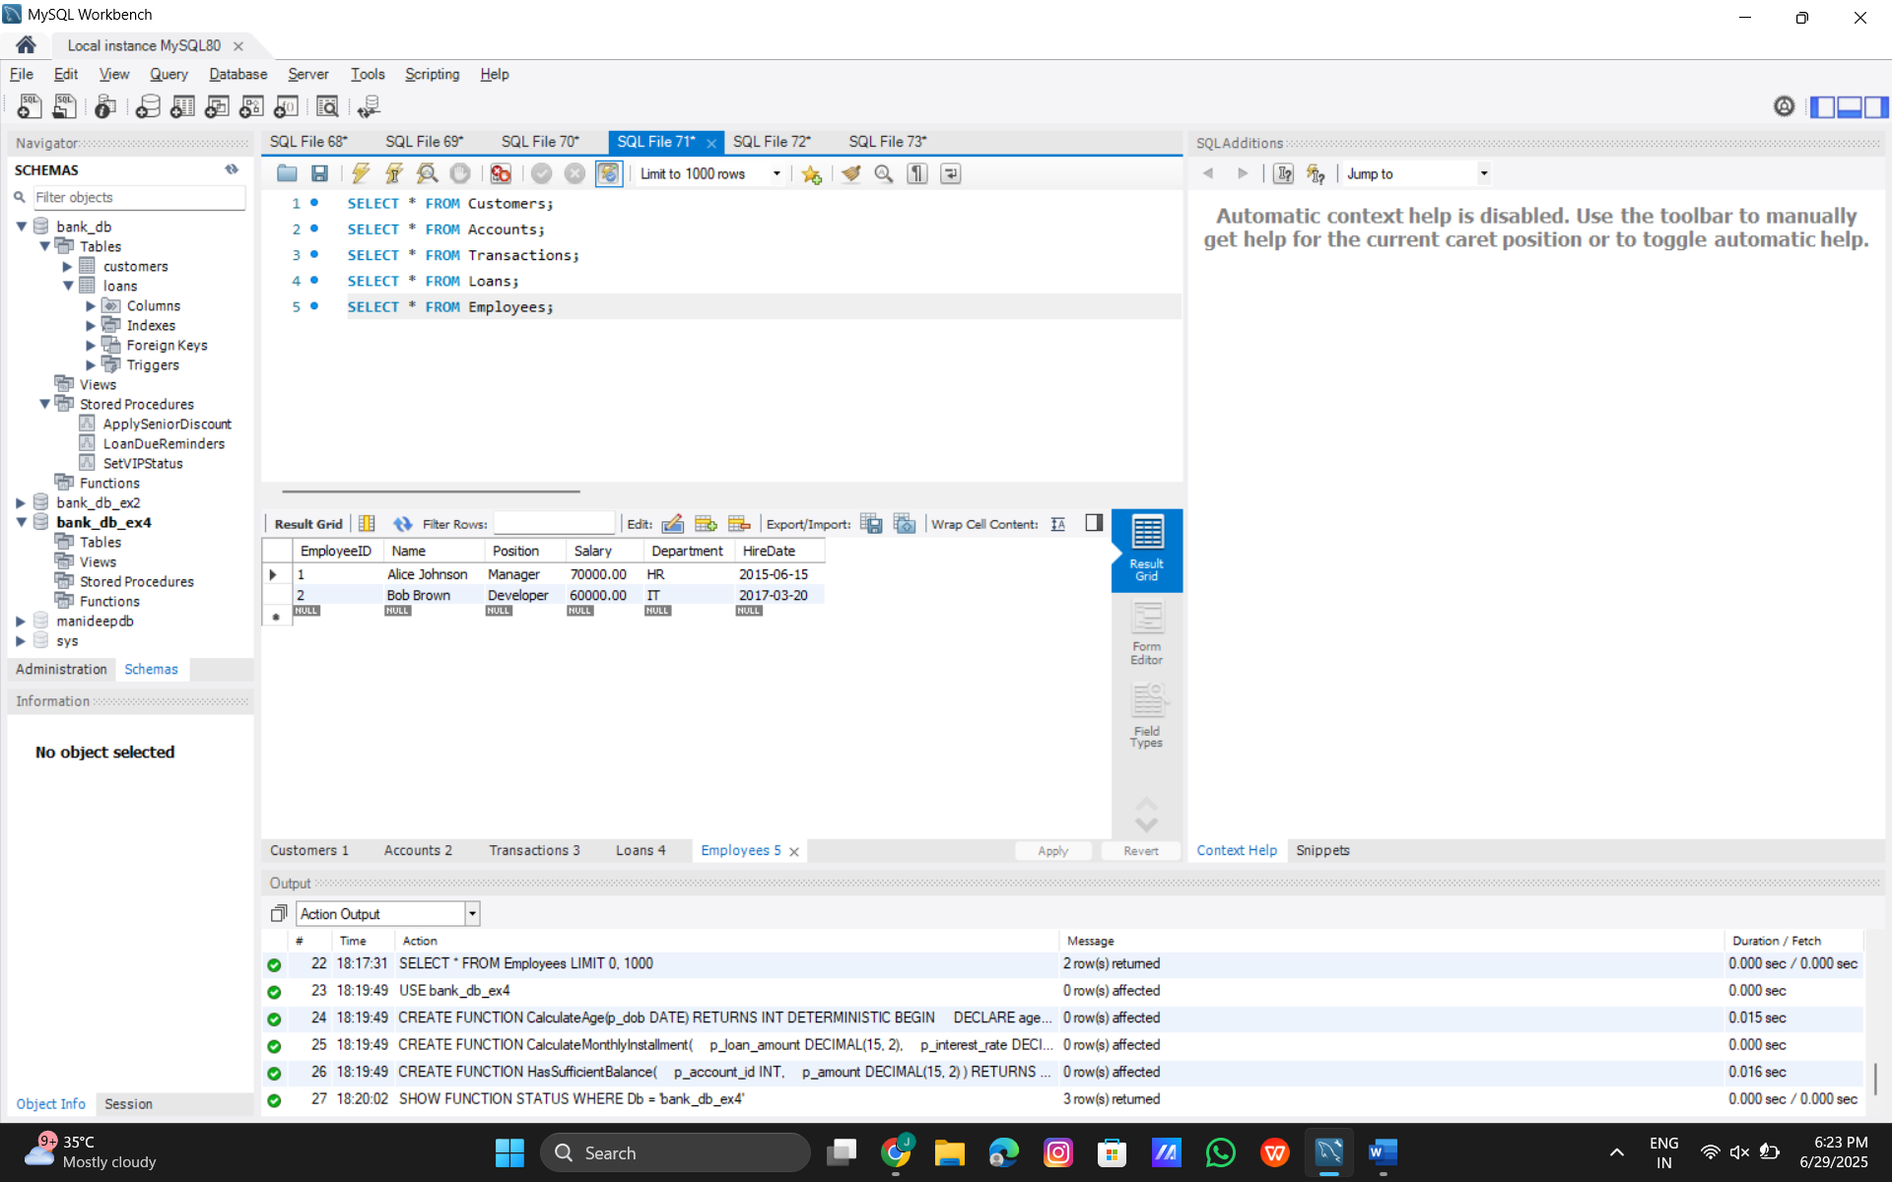

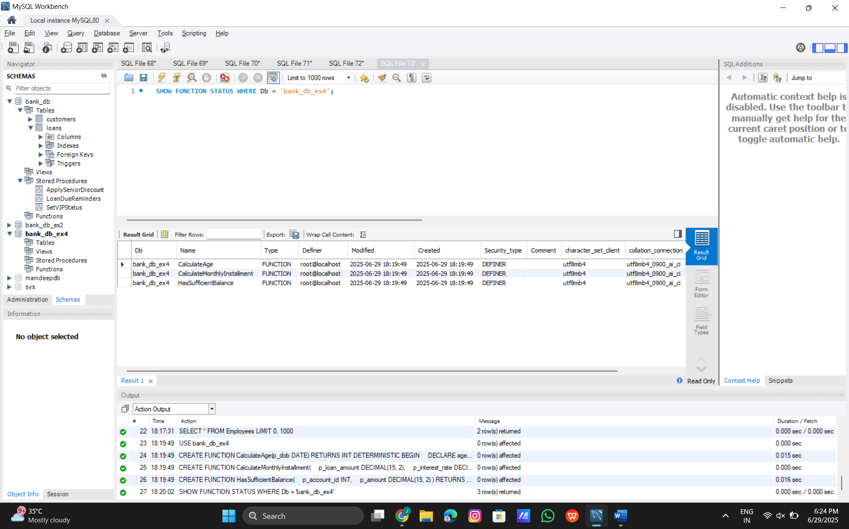

**Scenario 2:** **The bank needs to compute the monthly installment for a loan.**

**Calculate Monthly Installment:**

USE bank_db_ex4;

DELIMITER //

CREATE FUNCTION CalculateMonthlyInstallment(

p_loan_amount DECIMAL(15, 2),

p_interest_rate DECIMAL(5, 2),

p_duration_years INT

)

RETURNS DECIMAL(15, 2)

DETERMINISTIC

BEGIN

DECLARE monthly_rate DECIMAL(10, 6);

DECLARE num_payments INT;

DECLARE monthly_installment DECIMAL(15, 2);

SET monthly_rate = p_interest_rate / 100 / 12;

SET num_payments = p_duration_years * 12;

IF monthly_rate = 0 THEN

SET monthly_installment = p_loan_amount / num_payments;

ELSE

SET monthly_installment = p_loan_amount * monthly_rate *

POWER(1 + monthly_rate, num_payments) /

(POWER(1 + monthly_rate, num_payments) - 1);

END IF;

RETURN monthly_installment;

END //

DELIMITER ;

**Test Query:**

USE bank_db_ex4;

-- Test with sample loan data (LoanAmount = 5000, InterestRate = 5%, Duration = 5 years)

SELECT CalculateMonthlyInstallment(5000.00, 5.00, 5) AS MonthlyInstallment;

-- Test with data from Loans table

SELECT LoanID, CustomerID, LoanAmount, InterestRate,

CalculateMonthlyInstallment(LoanAmount, InterestRate, 5) AS MonthlyInstallment

FROM Loans

WHERE LoanID = 1;

**Output:**

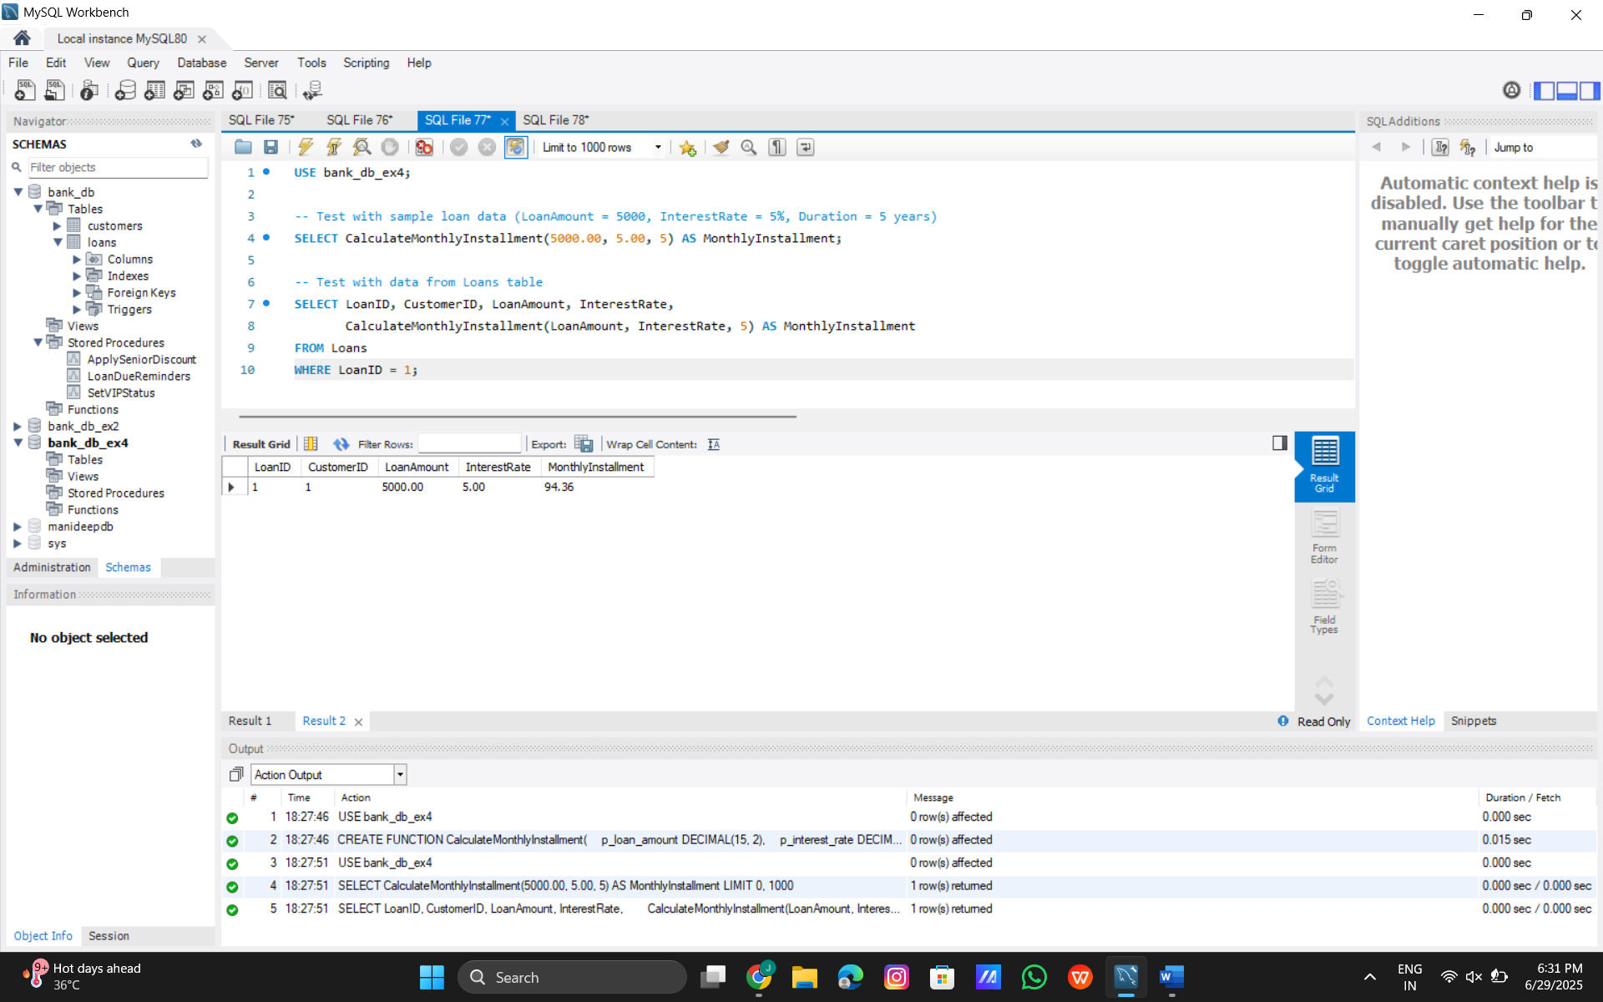

**Scenario 3:** **Check if a customer has sufficient balance before making a transaction.**

**Code:**

**Has Sufficient Balance**

USE bank_db_ex4;

DELIMITER //

CREATE FUNCTION HasSufficientBalance(

p_account_id INT,

p_amount DECIMAL(15, 2)

)

RETURNS BOOLEAN

DETERMINISTIC

BEGIN

DECLARE account_balance DECIMAL(15, 2);

SELECT Balance INTO account_balance

FROM Accounts

WHERE AccountID = p_account_id;

IF account_balance IS NULL THEN

RETURN FALSE;

END IF;

RETURN account_balance >= p_amount;

END //

DELIMITER ;

**Code**:

SHOW FUNCTION STATUS WHERE Db = 'bank_db_ex4' AND Name = 'HasSufficientBalance';

**Code**:

DROP FUNCTION IF EXISTS HasSufficientBalance;

**Test Query Code:**

USE bank_db_ex4;

-- Test with sample account data

SELECT AccountID, Balance,

HasSufficientBalance(AccountID, 500.00) AS HasEnoughBalance

FROM Accounts

WHERE AccountID = 1; -- Should return TRUE (Balance 1000.00 >= 500.00)

SELECT AccountID, Balance,

HasSufficientBalance(AccountID, 1500.00) AS HasEnoughBalance

FROM Accounts

WHERE AccountID = 1; -- Should return FALSE (Balance 1000.00 < 1500.00)

-- Test with non-existent account

SELECT HasSufficientBalance(999, 100.00) AS HasEnoughBalance; -- Should return FALSE

**Output:**

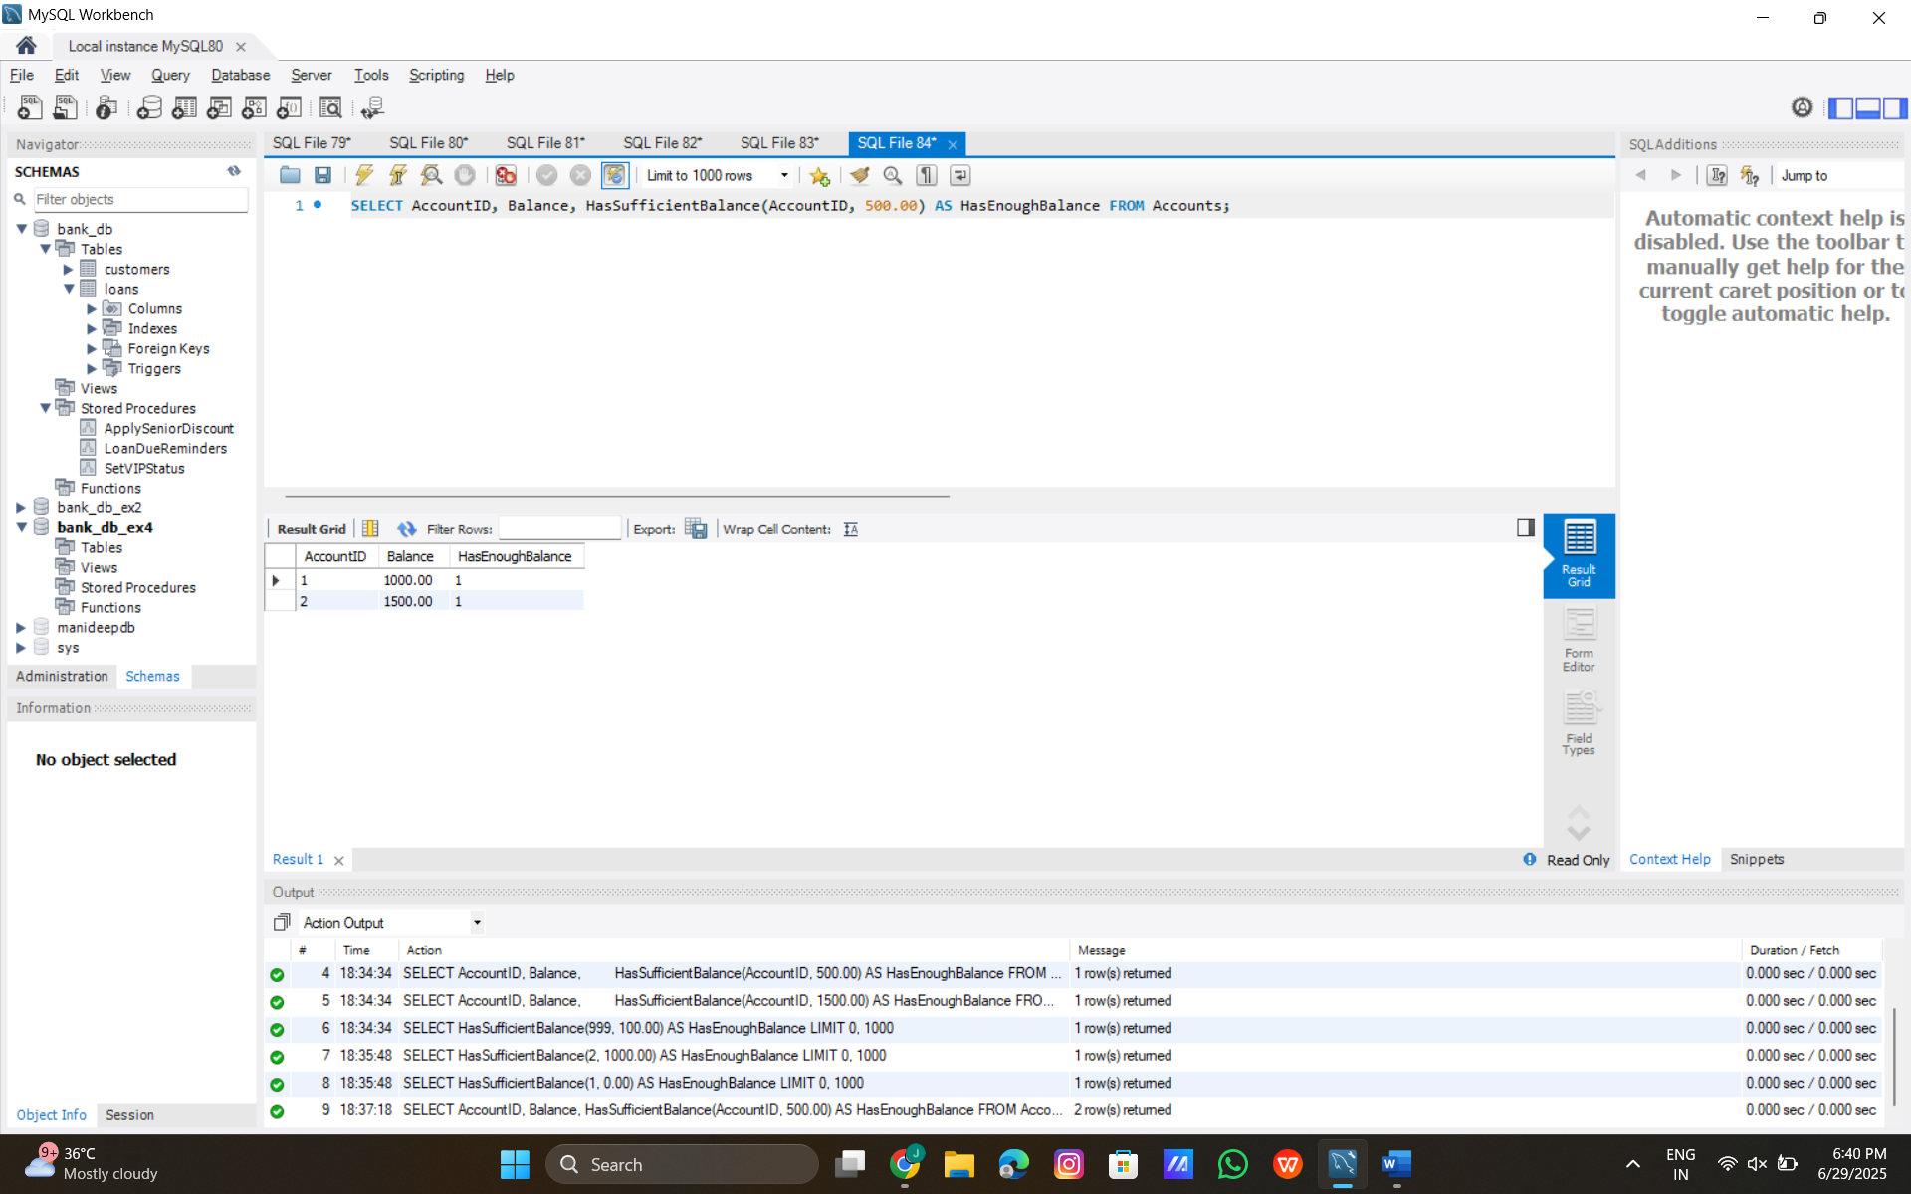

**Exercise 5: Triggers**

**Scenario 1: Automatically update the last modified date when a customer's record is updated.**

**MySQL Trigger Code:**

USE bank_db_ex4;

DELIMITER //

CREATE TRIGGER UpdateCustomerLastModified

BEFORE UPDATE ON Customers

FOR EACH ROW

BEGIN

SET NEW.LastModified = CURDATE();

END //

DELIMITER ;

**Code:**

SHOW TRIGGERS WHERE `Table` = 'Customers' AND `Trigger` = 'UpdateCustomerLastModified';

**Test Queries:**

USE bank_db_ex4;

-- Check initial LastModified value

SELECT CustomerID, Name, LastModified

FROM Customers

WHERE CustomerID = 1;

-- Update a customer record

UPDATE Customers

SET Balance = 1200.00

WHERE CustomerID = 1;

-- Check the updated LastModified value

SELECT CustomerID, Name, Balance, LastModified

FROM Customers

WHERE CustomerID = 1;

**Output:**

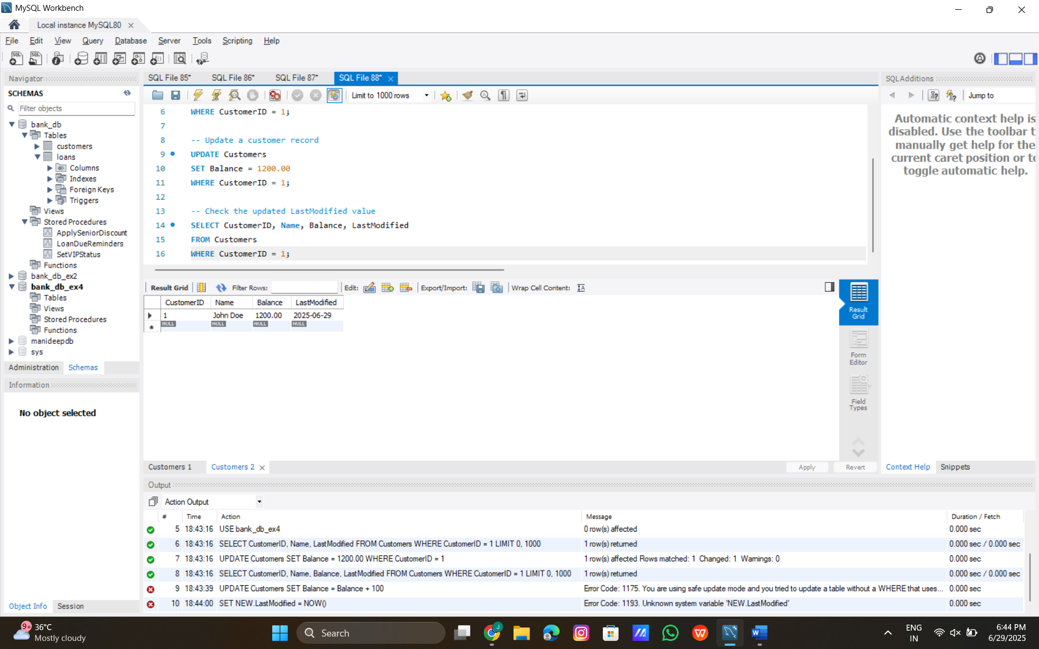

**Scenario 2: Maintain an audit log for all transactions.**

**Create AuditLog Table:**

USE bank_db_ex4;

CREATE TABLE AuditLog (

AuditLogID INT AUTO_INCREMENT PRIMARY KEY,

TransactionID INT,

AccountID INT,

Amount DECIMAL(15, 2),

TransactionType VARCHAR(10),

LogTimestamp DATETIME,

FOREIGN KEY (TransactionID) REFERENCES Transactions(TransactionID),

FOREIGN KEY (AccountID) REFERENCES Accounts(AccountID)

);

**MySQL Trigger Code:**

USE bank_db_ex4;

DELIMITER //

CREATE TRIGGER LogTransaction

AFTER INSERT ON Transactions

FOR EACH ROW

BEGIN

INSERT INTO AuditLog (TransactionID, AccountID, Amount, TransactionType, LogTimestamp)

VALUES (NEW.TransactionID, NEW.AccountID, NEW.Amount, NEW.TransactionType, NOW());

END //

DELIMITER ;

**Test Queries:**

USE bank_db_ex4;

-- Check initial AuditLog (should be empty)

SELECT * FROM AuditLog;

-- Insert a new transaction

INSERT INTO Transactions (TransactionID, AccountID, TransactionDate, Amount, TransactionType)

VALUES (3, 1, CURDATE(), 400.00, 'Deposit');

-- Check the AuditLog after insertion

SELECT * FROM AuditLog;

**Output:**

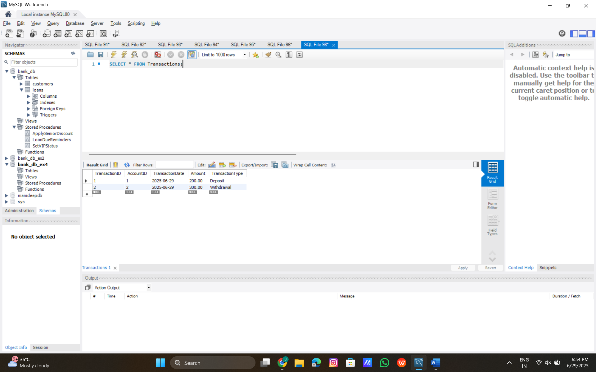

**Scenario 3: Enforce business rules on deposits and withdrawals**.

**MySQL Trigger Code:**

USE bank_db_ex4;

DELIMITER //

CREATE TRIGGER CheckTransactionRules

BEFORE INSERT ON Transactions

FOR EACH ROW

BEGIN

DECLARE current_balance DECIMAL(15, 2);

-- Get the current balance from the Accounts table

SELECT Balance INTO current_balance

FROM Accounts

WHERE AccountID = NEW.AccountID;

-- Check if the account exists (balance is not NULL)

IF current_balance IS NULL THEN

SIGNAL SQLSTATE '45000'

SET MESSAGE_TEXT = 'Error: Invalid AccountID. Account does not exist.';

END IF;

-- Check deposit rule: Amount must be positive for deposits

IF NEW.TransactionType = 'Deposit' AND NEW.Amount <= 0 THEN

SIGNAL SQLSTATE '45000'

SET MESSAGE_TEXT = 'Error: Deposit amount must be positive.';

END IF;

-- Check withdrawal rule: Amount must not exceed current balance

IF NEW.TransactionType = 'Withdrawal' AND NEW.Amount > current_balance THEN

SIGNAL SQLSTATE '45000'

SET MESSAGE_TEXT = 'Error: Withdrawal amount exceeds account balance.';

END IF;

END //

DELIMITER ;

**Test Queries:**

USE bank_db_ex4;

-- Test 1: Valid Deposit

INSERT INTO Transactions (TransactionID, AccountID, TransactionDate, Amount, TransactionType)

VALUES (5, 1, CURDATE(), 300.00, 'Deposit');

SELECT * FROM Transactions WHERE TransactionID = 5;

-- Test 2: Invalid Deposit (negative amount)

INSERT INTO Transactions (TransactionID, AccountID, TransactionDate, Amount, TransactionType)

VALUES (6, 1, CURDATE(), -100.00, 'Deposit');

-- Test 3: Valid Withdrawal

INSERT INTO Transactions (TransactionID, AccountID, TransactionDate, Amount, TransactionType)

VALUES (7, 1, CURDATE(), 500.00, 'Withdrawal');

SELECT * FROM Transactions WHERE TransactionID = 7;

-- Test 4: Invalid Withdrawal (exceeds balance)

INSERT INTO Transactions (TransactionID, AccountID, TransactionDate, Amount, TransactionType)

VALUES (8, 1, CURDATE(), 1500.00, 'Withdrawal');

-- Test 5: Invalid AccountID

INSERT INTO Transactions (TransactionID, AccountID, TransactionDate, Amount, TransactionType)

VALUES (9, 999, CURDATE(), 200.00, 'Deposit');

**Output:**

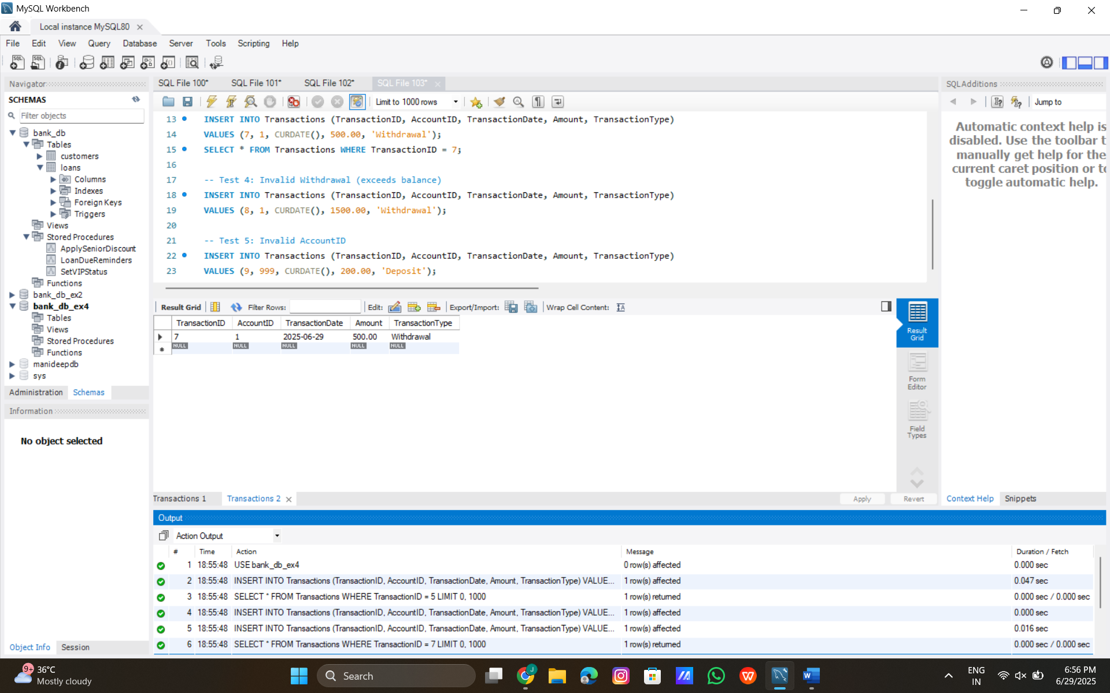

**Exercise 6: Cursors**

**Scenario 1: Generate monthly statements for all customers.**

**CREATE PROCEDURE**

USE bank_db_ex4;

-- Change delimiter to handle the procedure block

DELIMITER //

-- Create the procedure

CREATE PROCEDURE GenerateMonthlyStatements()

BEGIN

-- Declare variables

DECLARE done INT DEFAULT FALSE;

DECLARE v_transaction_id INT;

DECLARE v_account_id INT;

DECLARE v_customer_id INT;

DECLARE v_customer_name VARCHAR(100);

DECLARE v_amount DECIMAL(15, 2);

DECLARE v_transaction_type VARCHAR(10);

DECLARE v_transaction_date DATE;

-- Declare the explicit cursor for transactions in the current month (June 2025)

DECLARE cur_transactions CURSOR FOR

SELECT t.TransactionID, t.AccountID, c.CustomerID, c.Name, t.Amount, t.TransactionType, t.TransactionDate

FROM Transactions t

JOIN Accounts a ON t.AccountID = a.AccountID

JOIN Customers c ON a.CustomerID = c.CustomerID

WHERE MONTH(t.TransactionDate) = MONTH(CURDATE()) -- Current month: 6 (June)

AND YEAR(t.TransactionDate) = YEAR(CURDATE()); -- Current year: 2025

-- Handler for end of cursor data

DECLARE CONTINUE HANDLER FOR NOT FOUND SET done = TRUE;

-- Open the cursor

OPEN cur_transactions;

-- Loop through transactions

read_loop: LOOP

FETCH cur_transactions INTO v_transaction_id, v_account_id, v_customer_id, v_customer_name, v_amount, v_transaction_type, v_transaction_date;

IF done THEN

LEAVE read_loop;

END IF;

-- Output the statement (simulated print for MySQL Workbench)

SELECT CONCAT(

'Customer: ', COALESCE(v_customer_name, 'Unknown'), ' (ID: ', COALESCE(v_customer_id, 0), ')\n',

'Transaction ID: ', COALESCE(v_transaction_id, 0), '\n',

'Date: ', COALESCE(v_transaction_date, '0000-00-00'), '\n',

'Type: ', COALESCE(v_transaction_type, 'Unknown'), '\n',

'Amount: ', COALESCE(v_amount, 0.00), '\n',

) AS MonthlyStatement;

END LOOP;

-- Close the cursor

CLOSE cur_transactions;

END //

DELIMITER ;

**Code:**

SHOW PROCEDURE STATUS WHERE Db = 'bank_db_ex4' AND Name = 'GenerateMonthlyStatements';

**Code:**

SELECT DATABASE();

**Code:**

USE bank_db_ex4;

**Code:**

SHOW GRANTS;

**Code:**

GRANT CREATE ROUTINE ON bank_db_ex4.* TO 'root'@'localhost';

**Testcode:**

USE bank_db_ex4;

CALL GenerateMonthlyStatements();

**Output:**

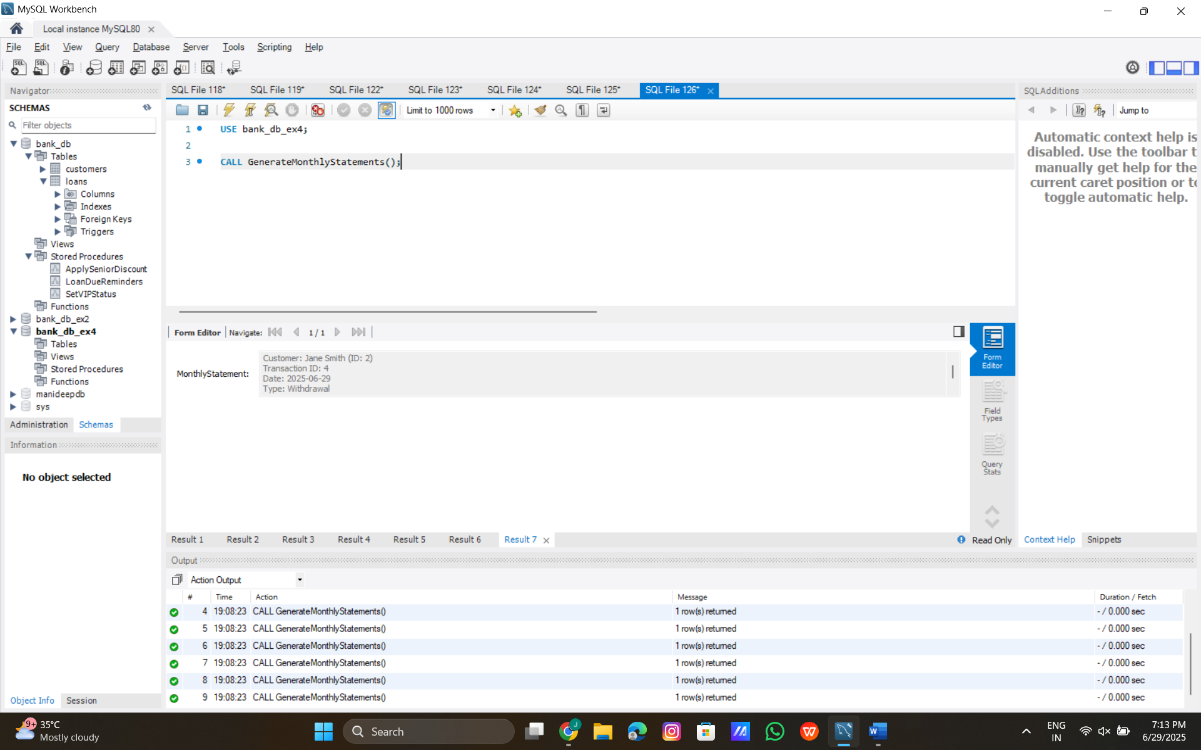

**Scenario 2:** **Apply annual fee to all accounts.**

**MySQL Stored Procedure with Explicit Cursor**

USE bank_db_ex4;

DELIMITER //

CREATE PROCEDURE ApplyAnnualFee()

BEGIN

-- Declare variables

DECLARE done INT DEFAULT FALSE;

DECLARE v_account_id INT;

DECLARE v_balance DECIMAL(15, 2);

DECLARE v_annual_fee DECIMAL(15, 2) DEFAULT 10.00; -- Assumed annual maintenance fee

-- Declare the explicit cursor for all accounts

DECLARE cur_accounts CURSOR FOR

SELECT AccountID, Balance

FROM Accounts;

-- Declare handler for when cursor reaches end

DECLARE CONTINUE HANDLER FOR NOT FOUND SET done = TRUE;

-- Open the cursor

OPEN cur_accounts;

-- Start loop to process each account

read_loop: LOOP

FETCH cur_accounts INTO v_account_id, v_balance;

IF done THEN

LEAVE read_loop;

END IF;

-- Check if balance is sufficient to deduct the fee

IF v_balance >= v_annual_fee THEN

-- Update the account balance and last modified date

UPDATE Accounts

SET Balance = Balance - v_annual_fee,

LastModified = CURDATE()

WHERE AccountID = v_account_id;

ELSE

-- Log insufficient balance (simulated output using SELECT)

SELECT CONCAT(

'Warning: Account ID ', v_account_id, ' has insufficient balance (',

v_balance, ') to deduct annual fee of ', v_annual_fee, '\n'

) AS WarningMessage;

END IF;

END LOOP;

CLOSE cur_accounts;

END //

DELIMITER ;

**Code:**

SHOW PROCEDURE STATUS WHERE Db = 'bank_db_ex4' AND Name = 'ApplyAnnualFee';

**Code:**

DROP PROCEDURE IF EXISTS ApplyAnnualFee;

**Test Query:**

USE bank_db_ex4;

-- Check initial balances

SELECT AccountID, Balance, LastModified FROM Accounts;

-- Call the procedure

CALL ApplyAnnualFee();

-- Check updated balances

SELECT AccountID, Balance, LastModified FROM Accounts;

**Output:**

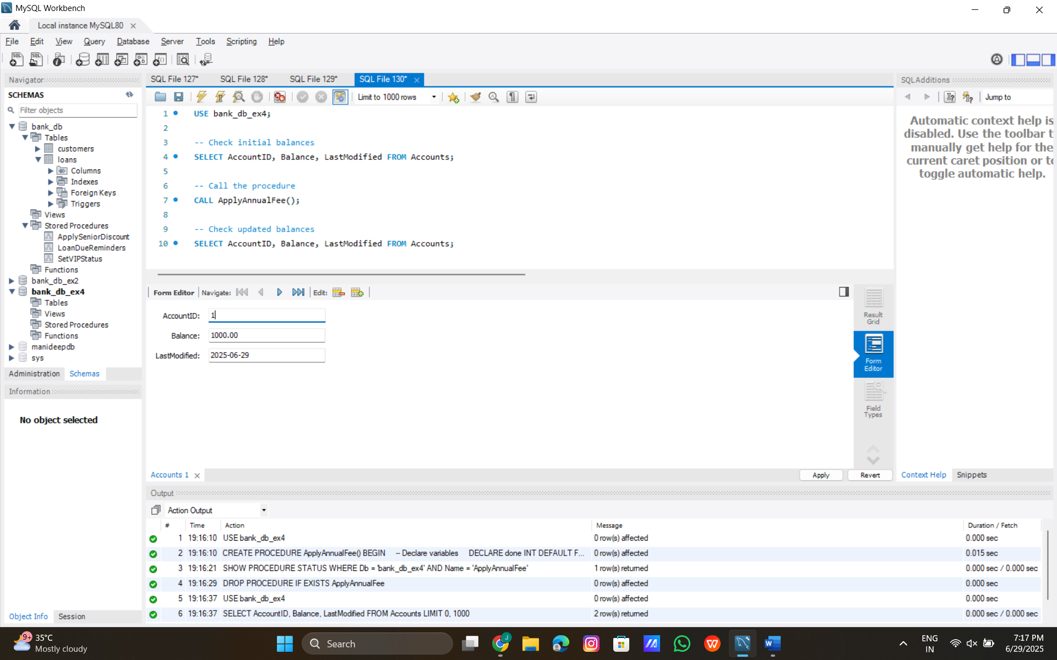

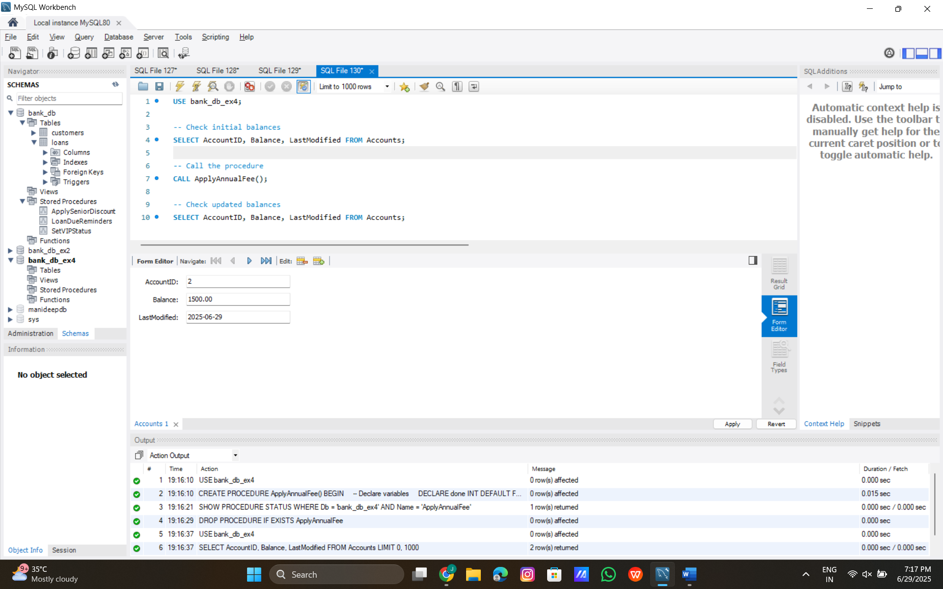

**Scenario 3:** **Update the interest rate for all loans based on a new policy.**

**CREATE PROCEDURE:**

USE bank_db_ex4;

DELIMITER //

CREATE PROCEDURE UpdateLoanInterestRates()

BEGIN

-- Declare variables

DECLARE done INT DEFAULT FALSE;

DECLARE v_loan_id INT;

DECLARE v_start_date DATE;

DECLARE v_end_date DATE;

DECLARE v_duration_years INT;

DECLARE v_new_interest_rate DECIMAL(5, 2);

-- Declare the explicit cursor for all loans

DECLARE cur_loans CURSOR FOR

SELECT LoanID, StartDate, EndDate

FROM Loans;

-- Declare handler for when cursor reaches end

DECLARE CONTINUE HANDLER FOR NOT FOUND SET done = TRUE;

-- Open the cursor

OPEN cur_loans;

-- Start loop to process each loan

read_loop: LOOP

FETCH cur_loans INTO v_loan_id, v_start_date, v_end_date;

IF done THEN

LEAVE read_loop;

END IF;

-- Check for valid dates before calculation

IF v_start_date IS NULL OR v_end_date IS NULL THEN

SELECT CONCAT(

'Error: Loan ID ', COALESCE(v_loan_id, 0), ' has invalid date(s) (Start: ', COALESCE(v_start_date, 'NULL'), ', End: ', COALESCE(v_end_date, 'NULL'), ')\n'

) AS ErrorMessage;

ITERATE read_loop;

END IF;

-- Calculate duration in years (approximate by year difference)

SET v_duration_years = FLOOR(DATEDIFF(v_end_date, v_start_date) / 365.25);

-- Ensure duration is non-negative

IF v_duration_years < 0 THEN

SELECT CONCAT(

'Error: Loan ID ', v_loan_id, ' has negative duration (', v_duration_years, ' years)\n'

) AS ErrorMessage;

ITERATE read_loop;

END IF;

-- Determine new interest rate based on duration

CASE

WHEN v_duration_years = 1 THEN SET v_new_interest_rate = 5.00;

WHEN v_duration_years = 2 THEN SET v_new_interest_rate = 6.00;

WHEN v_duration_years >= 3 THEN SET v_new_interest_rate = 7.00;

ELSE SET v_new_interest_rate = 0.00; -- Default case for invalid durations

END CASE;

-- Update the loan with the new interest rate and last modified date

UPDATE Loans

SET InterestRate = v_new_interest_rate,

LastModified = CURDATE() -- 2025-06-29

WHERE LoanID = v_loan_id;

-- Log the update (simulated output)

SELECT CONCAT(

'Loan ID: ', v_loan_id, '\n',

'Duration: ', v_duration_years, ' years\n',

'New Interest Rate: ', v_new_interest_rate, '%\n',

'------------------------'

) AS UpdateLog;

END LOOP;

-- Close the cursor

CLOSE cur_loans;

END //

DELIMITER ;

**Code:**

SHOW PROCEDURE STATUS WHERE Db = 'bank_db_ex4' AND Name = 'UpdateLoanInterestRates';

**Code:**

GRANT CREATE ROUTINE, UPDATE ON bank_db_ex4.* TO 'root'@'localhost';

**Test Query:**

USE bank_db_ex4;

-- Check initial loan details

SELECT LoanID, StartDate, EndDate, InterestRate, LastModified FROM Loans;

-- Call the procedure

CALL UpdateLoanInterestRates();

-- Check updated loan details

SELECT LoanID, StartDate, EndDate, InterestRate, LastModified FROM Loans;

**Output:**

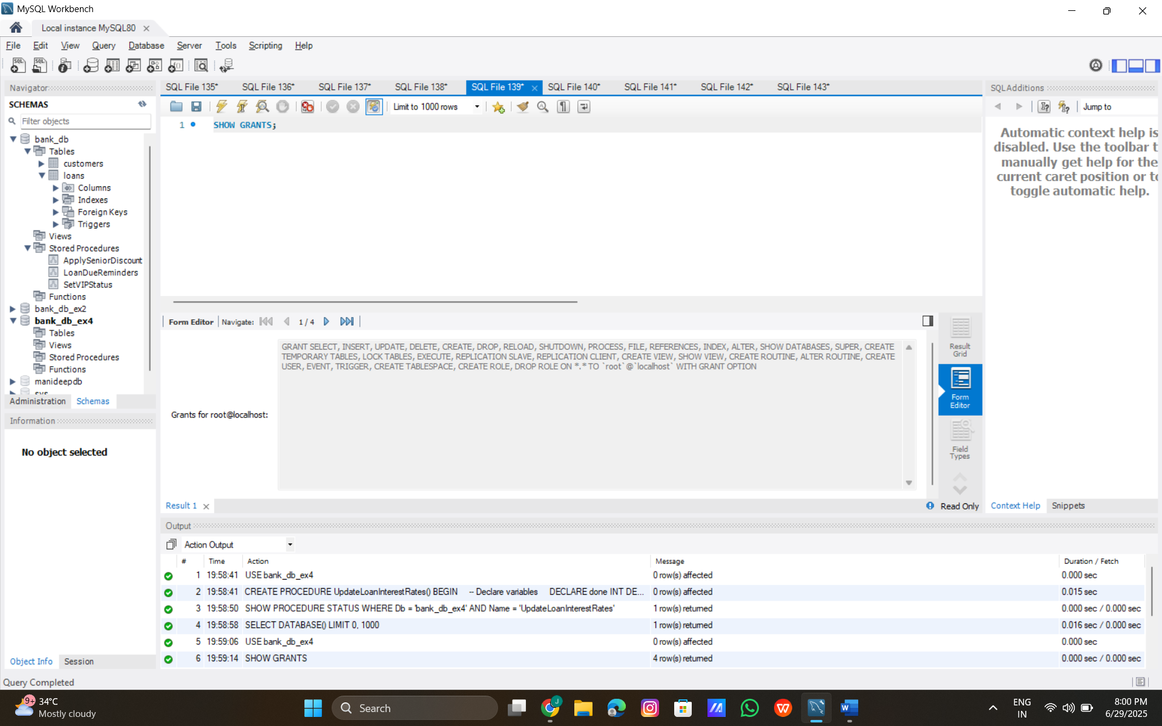

**Exercise 7: Packages**

**Scenario 1:** Group all customer-related procedures and functions into a package.

**MySQL Stored Procedure with Exception Handling**

USE bank_db_ex4;

DELIMITER //

CREATE PROCEDURE TransferFunds(

IN p_from_account_id INT,

IN p_to_account_id INT,

IN p_amount DECIMAL(15, 2)

)

BEGIN

-- Declare variables

DECLARE v_from_balance DECIMAL(15, 2);

DECLARE v_to_balance DECIMAL(15, 2);

DECLARE EXIT HANDLER FOR SQLEXCEPTION

BEGIN

-- Rollback on any SQL exception

ROLLBACK;

SELECT 'Error: Transaction failed due to an unexpected error.' AS ErrorMessage;

END;

-- Start transaction

START TRANSACTION;

-- Check if from_account exists and get balance

SELECT Balance INTO v_from_balance

FROM Accounts

WHERE AccountID = p_from_account_id;

IF v_from_balance IS NULL THEN

SIGNAL SQLSTATE '45000'

SET MESSAGE_TEXT = 'Error: Source account does not exist.';

END IF;

-- Check if to_account exists and get balance

SELECT Balance INTO v_to_balance

FROM Accounts

WHERE AccountID = p_to_account_id;

IF v_to_balance IS NULL THEN

SIGNAL SQLSTATE '45000'

SET MESSAGE_TEXT = 'Error: Destination account does not exist.';

END IF;

-- Check for sufficient balance

IF v_from_balance < p_amount THEN

SIGNAL SQLSTATE '45000'

SET MESSAGE_TEXT = 'Error: Insufficient balance in source account.';

END IF;

-- Perform the transfer

UPDATE Accounts

SET Balance = Balance - p_amount,

LastModified = CURDATE() -- 2025-06-29

WHERE AccountID = p_from_account_id;

UPDATE Accounts

SET Balance = Balance + p_amount,

LastModified = CURDATE() -- 2025-06-29

WHERE AccountID = p_to_account_id;

-- Commit the transaction

COMMIT;

-- Log the successful transfer

SELECT CONCAT(

'Transfer Successful:\n',

'From Account ID: ', p_from_account_id, '\n',

'To Account ID: ', p_to_account_id, '\n',

'Amount: ', p_amount, '\n',

'Date: ', CURDATE(), '\n',

'------------------------'

) AS TransferLog;

END //

DELIMITER ;

**Test Queries:**

USE bank_db_ex4;

-- Check initial balances

SELECT AccountID, Balance, LastModified FROM Accounts;

-- Test 1: Valid transfer

CALL TransferFunds(1, 2, 300.00);

-- Check updated balances

SELECT AccountID, Balance, LastModified FROM Accounts;

-- Test 2: Insufficient balance

CALL TransferFunds(1, 2, 800.00);

-- Test 3: Invalid source account

CALL TransferFunds(999, 2, 100.00);

-- Test 4: Invalid destination account

CALL TransferFunds(1, 999, 100.00);

**Output:**

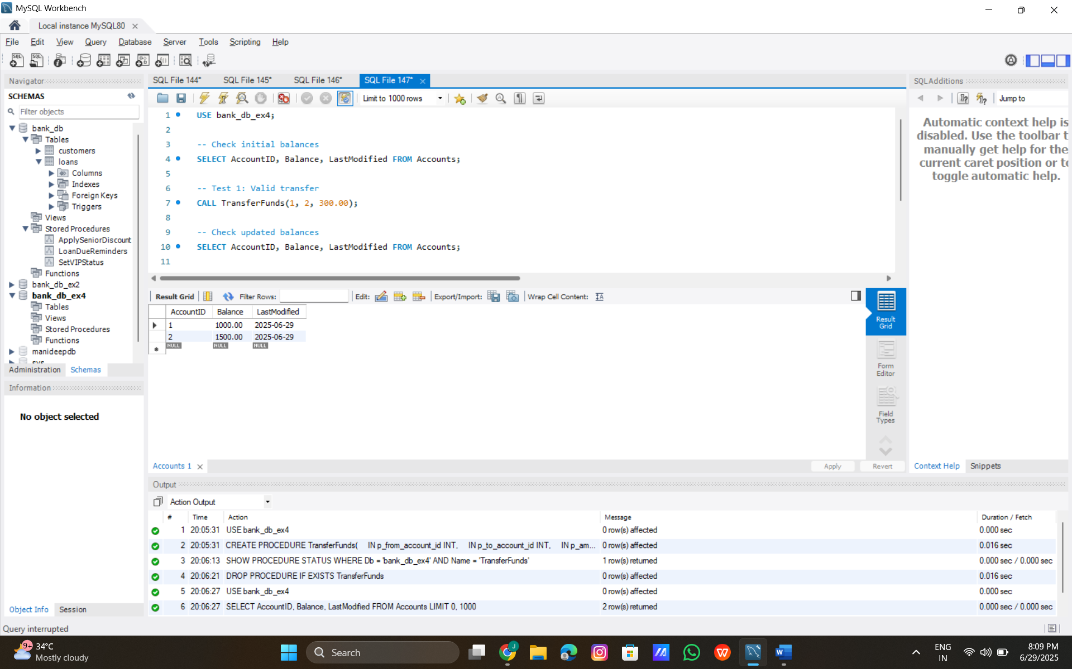

**Scenario 3: Group all account-related operations into a package.**

**MySQL Stored Procedure with Exception Handling**

USE bank_db_ex4;

DELIMITER //

CREATE PROCEDURE CloseAccount(

IN p_account_id INT

)

BEGIN

-- Declare variables

DECLARE v_balance DECIMAL(15, 2);

DECLARE v_loan_count INT;

DECLARE v_recent_transaction_count INT;

DECLARE EXIT HANDLER FOR SQLEXCEPTION

BEGIN

-- Rollback on any SQL exception

ROLLBACK;

SELECT 'Error: Transaction failed due to an unexpected error.' AS ErrorMessage;

END;

-- Start transaction

START TRANSACTION;

-- Check if account exists and get balance

SELECT Balance INTO v_balance

FROM Accounts

WHERE AccountID = p_account_id;

IF v_balance IS NULL THEN

SIGNAL SQLSTATE '45000'

SET MESSAGE_TEXT = 'Error: Account ID does not exist.';

END IF;

-- Check if balance is zero

IF v_balance <> 0 THEN

SIGNAL SQLSTATE '45000'

SET MESSAGE_TEXT = 'Error: Account balance must be zero to close.';

END IF;

-- Check for active loans (OutstandingBalance > 0) linked via CustomerID

SELECT COUNT(*) INTO v_loan_count

FROM Loans l

JOIN Accounts a ON l.CustomerID = a.CustomerID

WHERE a.AccountID = p_account_id AND l.OutstandingBalance > 0;

IF v_loan_count > 0 THEN

SIGNAL SQLSTATE '45000'

SET MESSAGE_TEXT = 'Error: Account has active loans.';

END IF;

-- Check for recent transactions (last 1 year)

SELECT COUNT(*) INTO v_recent_transaction_count

FROM Transactions

WHERE AccountID = p_account_id

AND TransactionDate >= DATE_SUB(CURDATE(), INTERVAL 1 YEAR); -- Last year from 2025-06-29

IF v_recent_transaction_count > 0 THEN

SIGNAL SQLSTATE '45000'

SET MESSAGE_TEXT = 'Error: Account has recent transactions.';

END IF;

-- Update LastModified before deletion

UPDATE Accounts

SET LastModified = CURDATE() -- 2025-06-29

WHERE AccountID = p_account_id;

-- Delete the account

DELETE FROM Accounts

WHERE AccountID = p_account_id;

-- Commit the transaction

COMMIT;

-- Log the successful closure

SELECT CONCAT(

'Account Closed Successfully:\n',

'Account ID: ', p_account_id, '\n',

'Date: ', CURDATE(), '\n',

'------------------------'

) AS ClosureLog;

END //

DELIMITER ;

**Code:**

SHOW PROCEDURE STATUS WHERE Db = 'bank_db_ex4' AND Name = 'CloseAccount';

**Code:**

DROP PROCEDURE IF EXISTS CloseAccount;

**Test Queries:**

USE bank_db_ex4;

-- Check initial data

SELECT a.AccountID, a.Balance, a.LastModified, l.LoanID, l.OutstandingBalance, l.LastModified, t.TransactionID, t.TransactionDate

FROM Accounts a

LEFT JOIN Loans l ON a.CustomerID = l.CustomerID

LEFT JOIN Transactions t ON a.AccountID = t.AccountID

WHERE a.AccountID = 1;

-- Test 1: Valid closure (balance 0, no active loans, no recent transactions)

CALL CloseAccount(1);

-- Check if account is deleted

SELECT AccountID, Balance, LastModified FROM Accounts WHERE AccountID = 1;

-- Test 2: Non-zero balance (re-insert account)

INSERT INTO Accounts (AccountID, CustomerID, AccountType, Balance, LastModified)

VALUES (1, 1, 'Checking', 100.00, CURDATE());

CALL CloseAccount(1);

-- Test 3: Active loan (update loan balance)

UPDATE Loans SET OutstandingBalance = 500.00 WHERE LoanID = 1;

CALL CloseAccount(1);

-- Test 4: Recent transaction (insert recent transaction)

INSERT INTO Transactions (TransactionID, AccountID, TransactionDate, Amount, TransactionType)

VALUES (2, 1, CURDATE(), 200.00, 'Deposit');

CALL CloseAccount(1);

-- Test 5: Invalid account ID

CALL CloseAccount(999);

**Output:**

